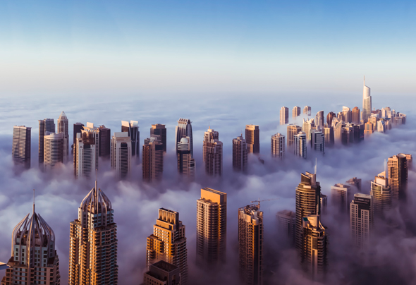

## Capstone Project

Battle of neighborhoods

Urna Semper

### Introduction to the

# Business problem

Dubai is a very dynamic city with many different neighborhoods both in the old/historic part of the city, which existed before discovery of oil and subsequent boost of economy, and the new part of the city full of magnificent masterminds of world renown architects. A lot of international workers or so called expats are moving to Dubai every year, some bringing along their families and loved ones. And this is when the key challenge arises - where to rent/buy an apartment/house?

Each person or a family will have a certain set of criteria for choosing a home, starting from availability of a supermarket in a close proximity, presence of playgrounds/parks and nearby schools/nurseries, to variety of restaurants and cafes around the corner.

The business problem that I have chosen for the project is **identification of the most suitable neighborhood based on criteria provided by the client**, who could be a real estate agent trying to serve the client or the prospective tenants/owners themselves.

# Description of data

The main component of data to be used for this project is the data provided by Foursquare API about the neighborhoods in Dubai along with venues of various categories. Neighborhoods will be considered as family friendly if for instance there are nurseries/schools, playgrounds or parks, grocery stores, gyms, recreational facilities located in them.